Assignment 9.4

1. Setting breaking points
   1. Press F12 inside Chrome browser
   2. Navigate to a .js file, such as this from Google.com. 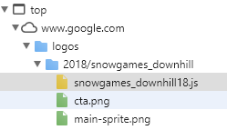
   3. Click on “Event Listener Breakpoints”. For this exercise, tick the “Mouse” box. 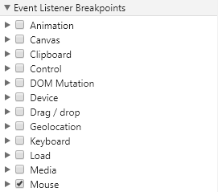
   4. Click the “Activate/Deactivate Breakpoints” button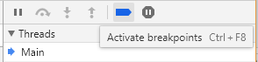
   5. Your breakpoints are now active and any actions involving the mouse, such as mouseover, click, mousewheel, etc. will pause the code:

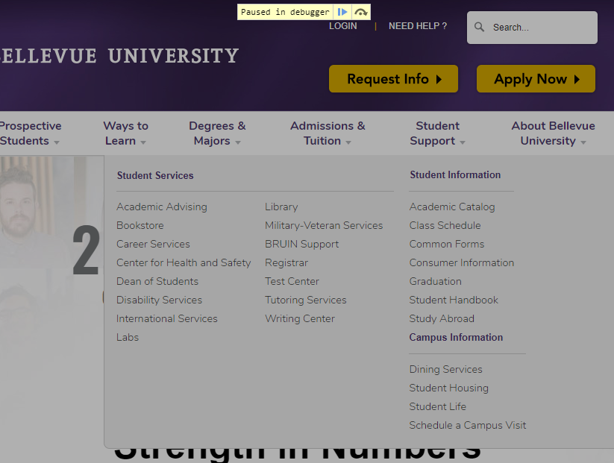

1. Log and read messages from JavaScript console window
   1. To locate the console window, click the console tab

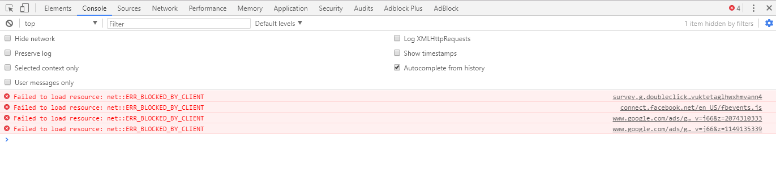

* 1. Here, you can read the messages from console window. In step 3, we’ll type into this window to log and read our outputs.

1. Select HTML elements in JavaScript console window
   1. To select html elements within the console window, first find an item such as this in the html code

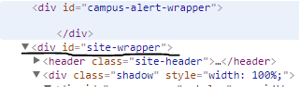

* 1. Next, locate the console menu

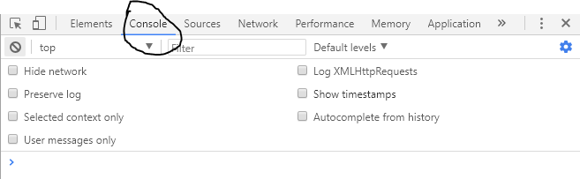

* 1. The element we wanted to get was id’d with “site-wrapper”. We’ll type document.getElementById(id) and place the id within the parenthesis, like this.

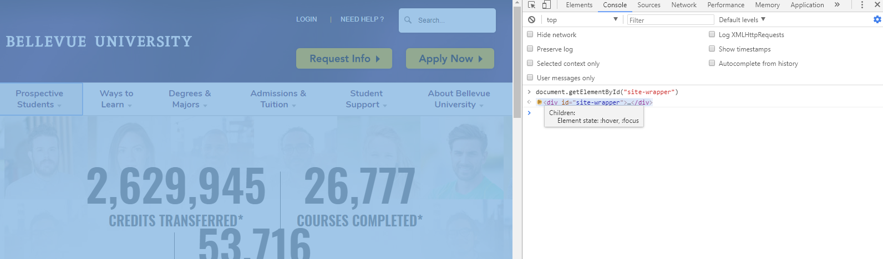

1. Simulate CSS states (hover/focus) on live HTML elements
   1. To simulate CSS states, we must first find an item we want to focus on. Take this Bellevue.Edu element

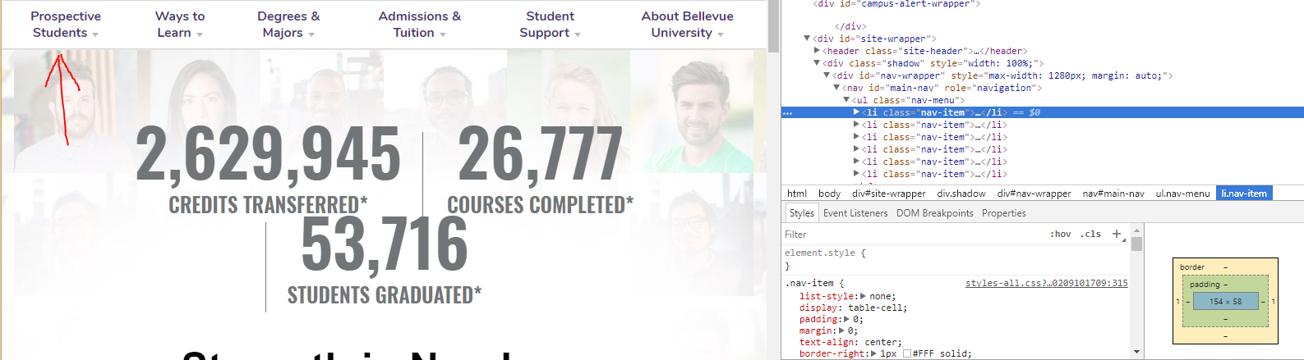

* 1. Notice it is not currently affected by the hover or focus state. By right clicking on its code (highlighted on the right), we can bring up this menu.

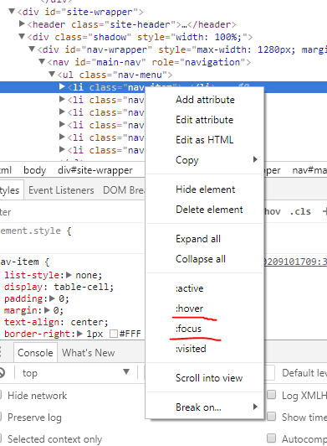

* 1. The underlined hover and focus option will simulate the element as if it were hovered or focused on. Here is the difference.

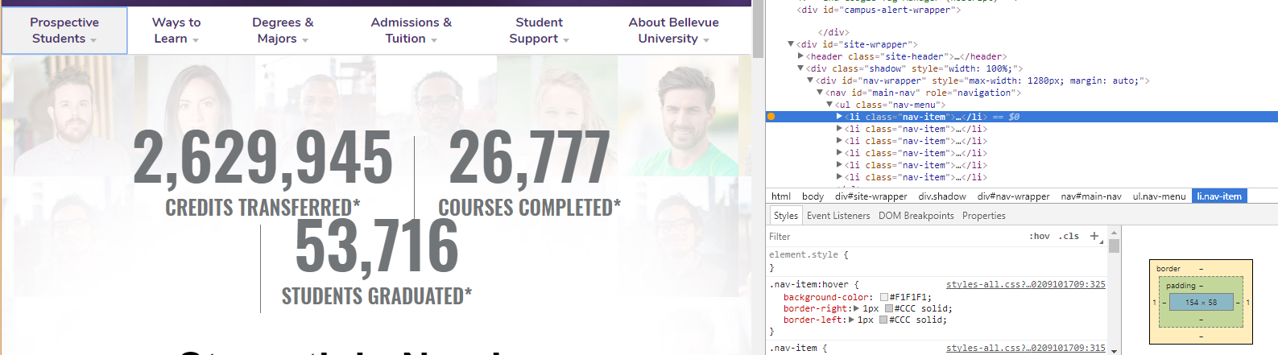

* 1. You can notice that the element is now gray with a blue box around it.